Quality Improvement Program – New Jersey (QIP-NJ)
Maternal Learning Collaborative (MLC)
Data Submission Guide
Contents
Introduction 1
Security & Confidentiality Statement 2
I. Requesting MLC Portal Access 2
II. Data Submission Survey 2
III. Data Visualization Tool 5
IV. Sampling 8
V. Troubleshooting 8

Introduction
The purpose of this document is to provide guidance about data submission in the QIP-NJ MLC. It is meant to be used concurrently with the Measurement Strategy, which provides definitions of each measure that will be used in the MLC along with options and guidance for data collection. This document gives a detailed explanation of the survey tool that will be used to submit MLC data, and an overview of a Data Visualization Tool intended to support hospitals.
Starting in November 2022, hospitals participating in the MLC will submit data to the Department of Health (the state) every month. Hospitals should plan to submit data on seven monthly measures and one quarterly measure to support their improvement process. The first submission date will begin on November 15, 2022, and subsequent submission due dates will be the 15th of each month (e.g., October data will be due on November 15, November data will be due on December 15, etc.).

The MLC Data Submission Survey is a Jotform survey. Hospitals should complete the survey to the best of their ability, with the aim of reporting on all measures; however, hospitals will not be penalized for incomplete data. Further, data collected in the MLC will not impact payments in the Pay-for-Performance side of QIP-NJ.¹
The Data Visualization Tool is meant to provide teams with a supportive resource to help teams track data each month while auto-generating run charts to view data over time. This Data Visualization Tool is meant for hospital team internal use only and is not required to be used by hospital teams or submitted to the State.
If you have questions regarding the MLC data collection process, please email QIP-NJ@pcgus.com.

Security & Confidentiality Statement
The State, in partnership with Public Consulting Group LLC (PCG), remains committed to maintaining strict security and confidentiality standards. The State and PCG will securely handle and store sensitive participant and provider information in accordance with Health Insurance Portability and Accountability Act (HIPAA) requirements. For the purposes of the MLC, hospitals should never be submitting patient level data or patient identifying information. Numerator and denominator results submitted in the Data Collection Tool for each measure will be used by the MLC team to calculate performance results for MLC measures. Performance results for all hospitals will be deidentified and shared in MLC events to promote shared learning and identify strengths and opportunities for improvement across participating hospitals.

I. Requesting MLC Portal Access
Please follow the steps below to request access to the MLC Participant Portal:
- Send an email to QIP-NJ@pcgus.com with your MLC team leader copied, requesting login credentials.
- The QIP-NJ Team will review requests weekly and respond to the request via email confirming or denying the request.
- If the request is approved, hospitals will receive a confirmation email with their username and a second, separate email with their password.

II. Data Submission Survey
On the fifteenth of each month, hospitals will submit their numerator and denominator data for each MLC measure via a Jotform survey. Hospitals will receive a reminder one week in advance of the submission date each month. Assuming you’ve received your MLC Participant Portal Login credentials, then there are several ways to access the MLC Data Submission Survey.
- Access the MLC Data Submission Survey:
  - In any web browser (google Chrome recommended), navigate to the following URL: https://pcgus.jotform.com/222694572541864.
  - You can also find the link to the Data Submission Survey by navigating to the LC page of the QIP-NJ website, then logging into the Participant Portal and navigating to Program Materials page.

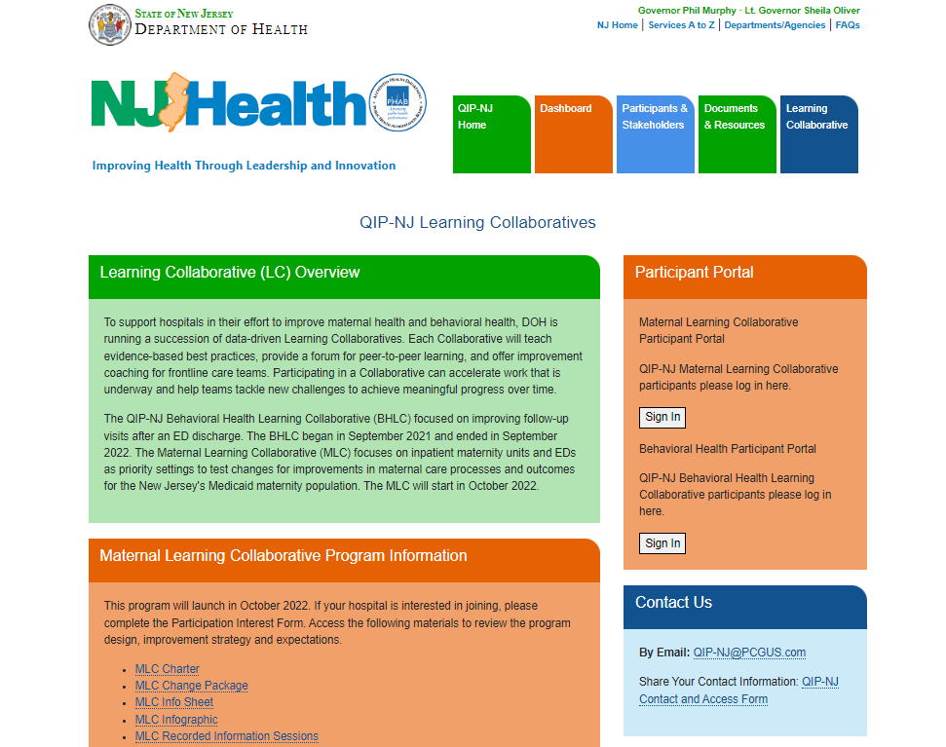

- Either method of accessing the survey takes you to the beginning of the survey shown below:

Page 1-3: Includes submission details and general contact information.

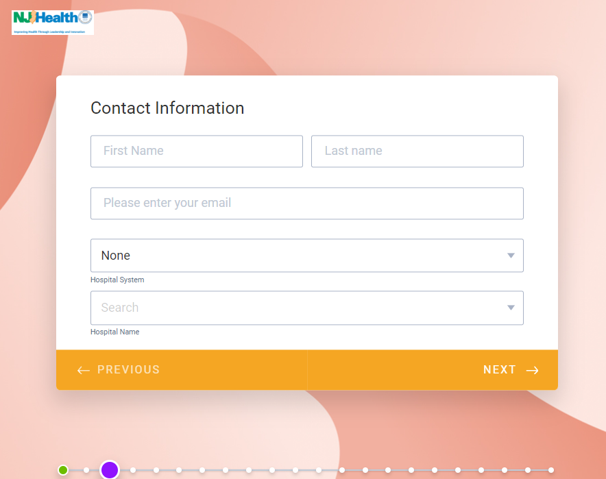

- Page 4-6: Please select all relevant secondary drivers that describe the tests of change your team performed in the previous month. Page 5 and 6 include additional follow up questions addressing your hospital’s tests of change. Page 6, in which you describe your past month’s test of change, is an essential question that will help the MLC team identify what teams are working on and how we can best provide coaching and resources to teams.

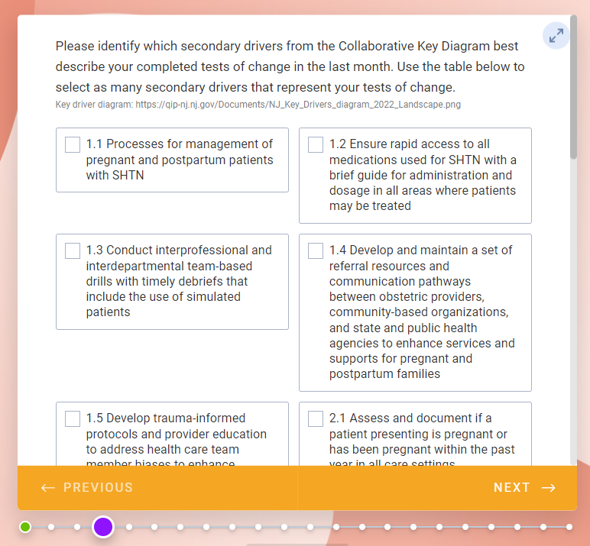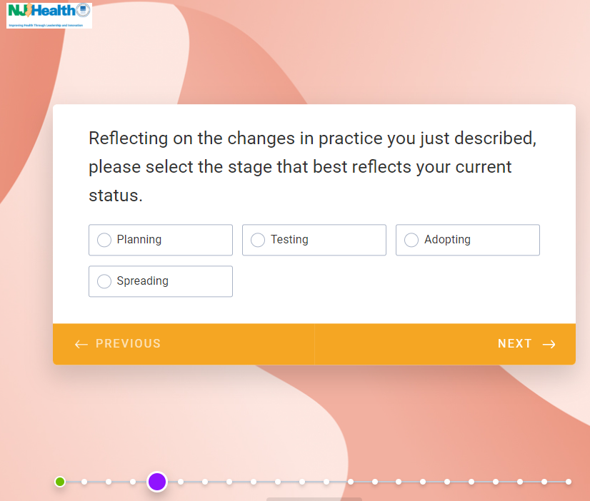

- Page 7-15 In these sections, hospitals should submit their monthly data, answering all questions to the best of your ability. Hospitals should submit the numerator and denominator for each measure. If you do not have the data for a measure, please enter a denominator and numerator value of ‘0’. There will be options for teams who have their data stratified by race and ethnicity (and those who do not). We encourage teams in the MLC to work towards stratifying your data by race and ethnicity.

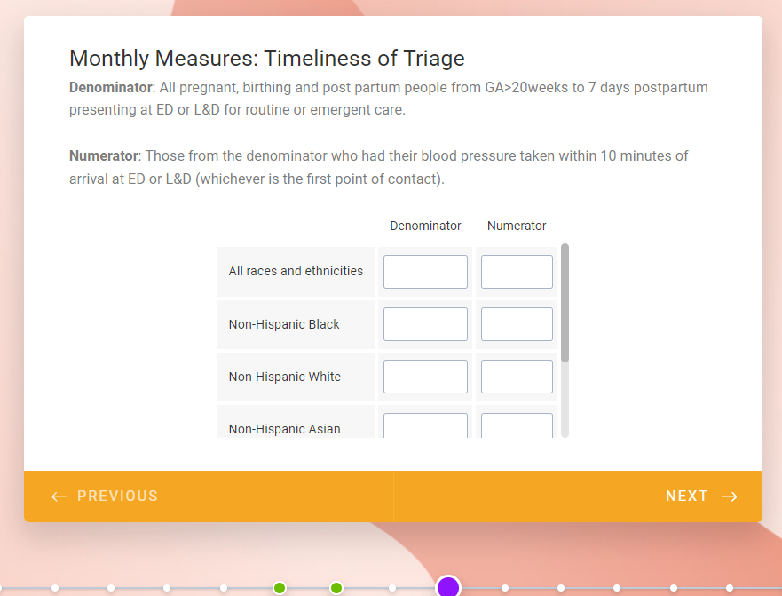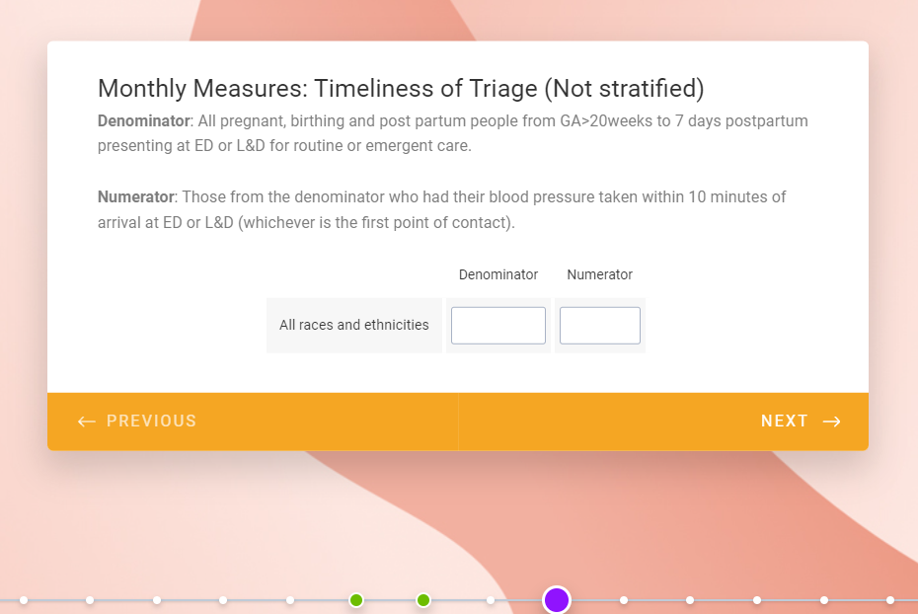

- Page 16-17: These questions ask teams how they are collecting patient experience data. For method, please choose one of the options provided. If no maternal surveys have been collected that month, please insert a “0” into the data field.
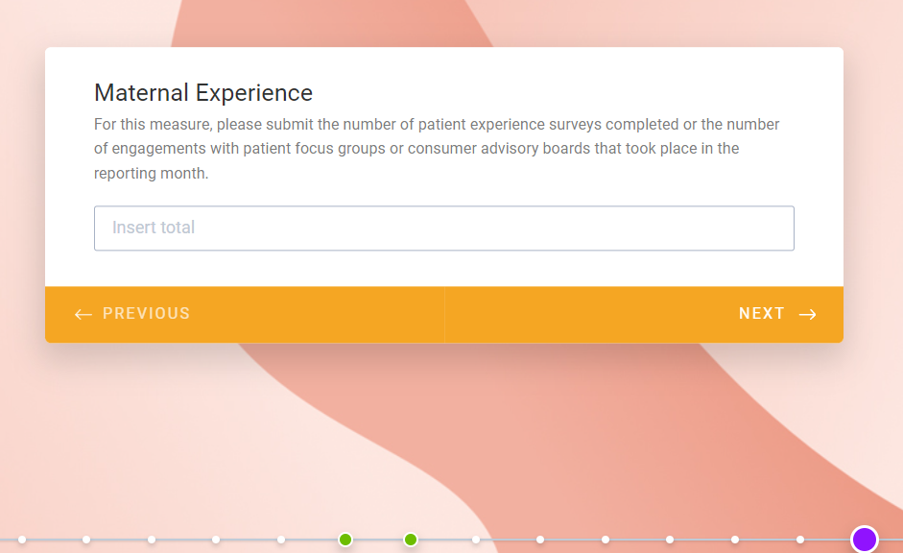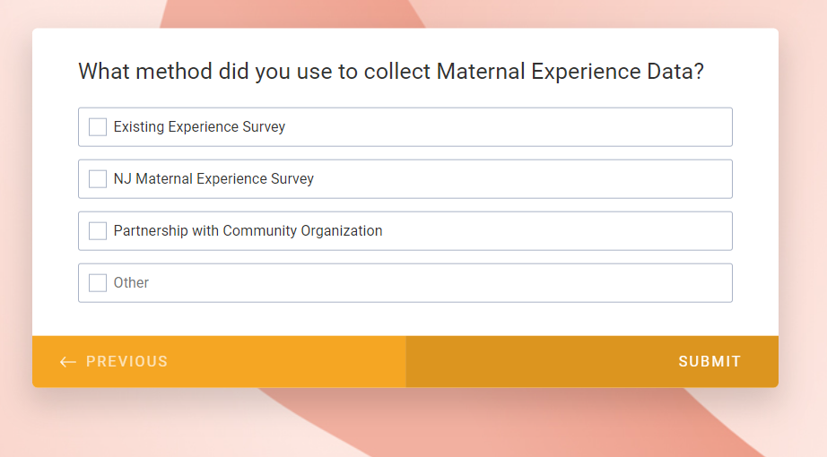
- The Quarterly measure (Clinical Education) will appear in the survey when you are submitting data for the months of February '23, June '23, and September '23. Additionally, the Treatment of SHTN measure appears as a monthly measure, but you can submit this measure quarterly if you have small denominators (less than 5), as indicated in the measurement strategy. However, if you will submit this measure quarterly, we do encourage teams to review each case internally month by month to determine if targets were met and what can be done if they were not.
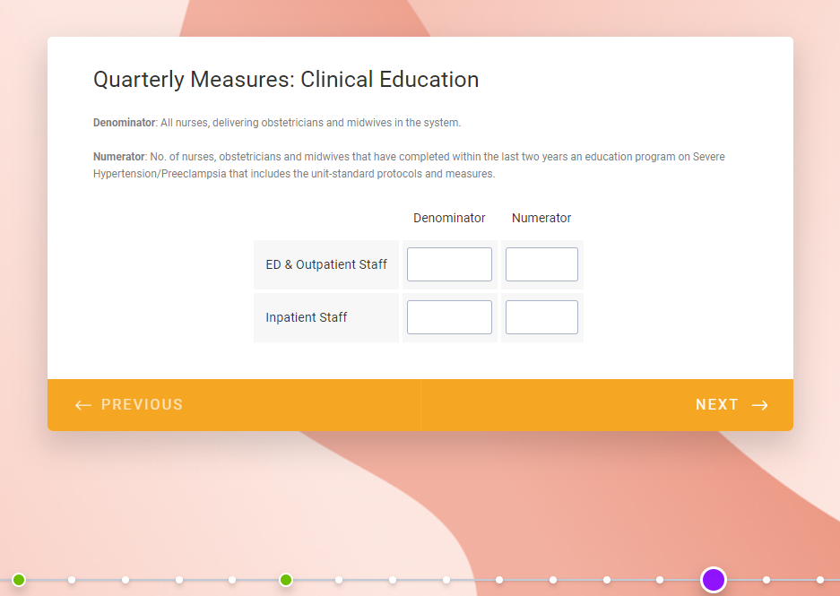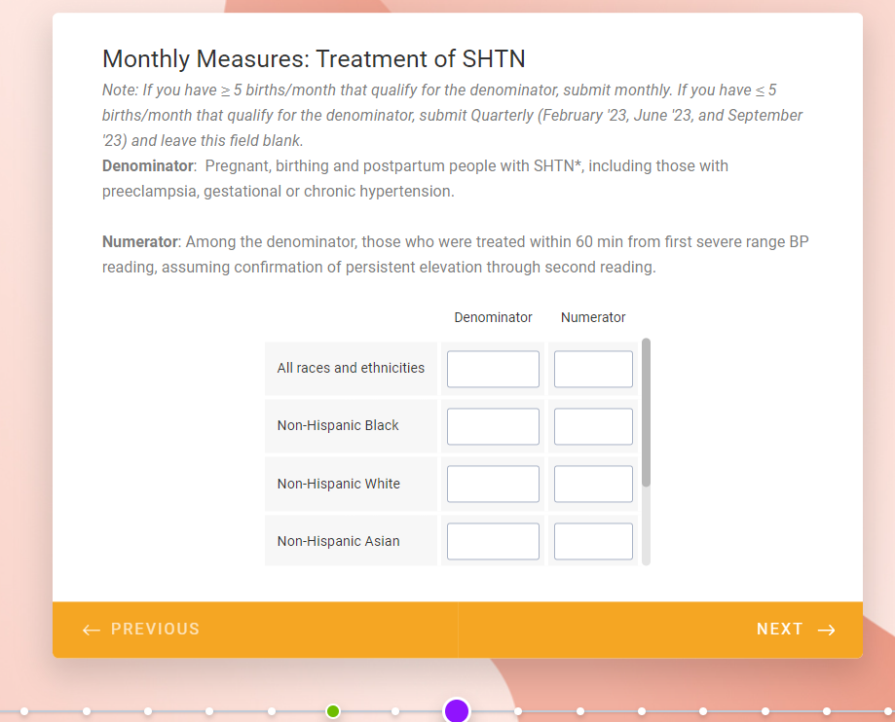
- When you have submitted your survey, please review the submission summary at the end of the survey to validate that your entries are accurate. If you have submitted an error, please resubmit and email QIP-NJ@pcgus.com to retract your previous entry.
- A confirmation email will be sent confirming the receipt of your submission.

III. Data Visualization Tool
The MLC Data Visualization Tool is an optional resource meant to provide hospitals with a way to track the data submissions internally and provide auto-generated run charts that allow hospitals to view their performance data over time for each measure. Hospitals are not required to submit this template each month. It is intended to be a supportive tool for participating teams. To access the template, please see the following:

- In any web browser, navigate to the QIP-NJ website. Navigate to the LC page where you can find the link to the Participant Portal. See Section I of this document for information on how to receive credentials to access the Participant Portal.

- Use your login credentials to navigate to the Program Materials page and download the Data Visualization Tool.

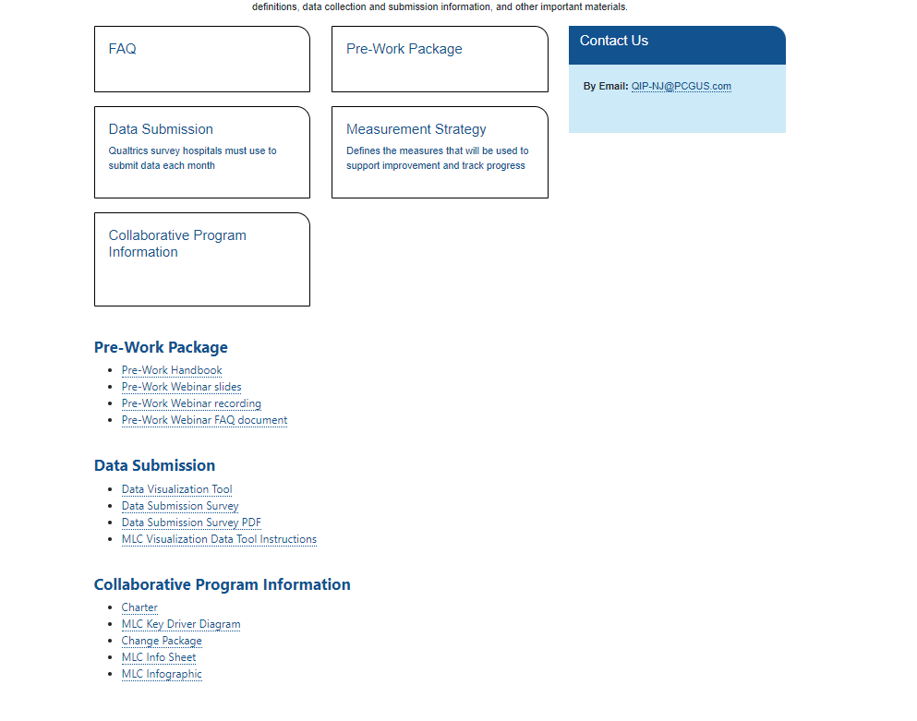
- Review the first tab, “MLC DVT Instructions” to understand the general guidelines regarding the use of the template.

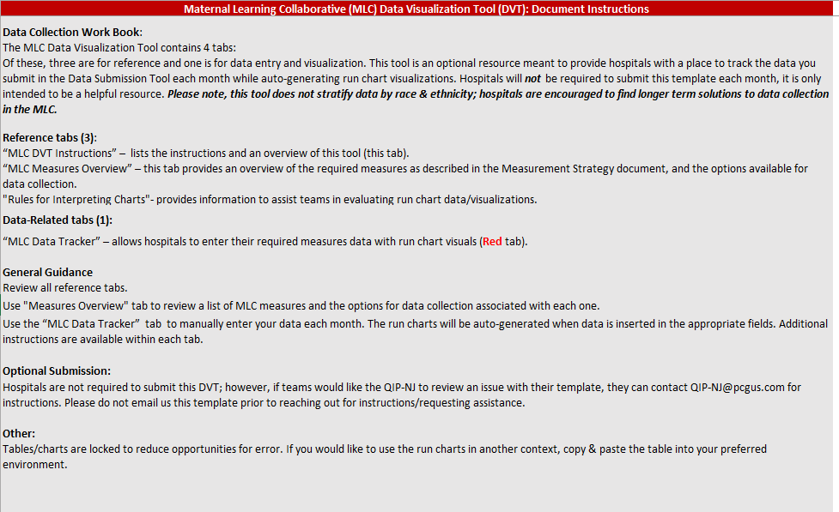
- When entering data into the Data tracker, please follow the instructions provided on the left side of the table. Do not make any changes to the month or measure columns. These are fixed and should not be edited.
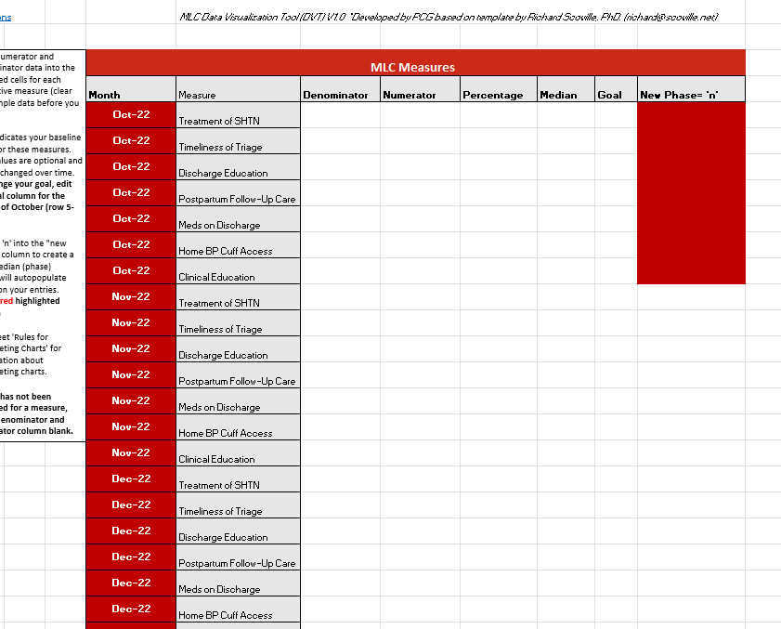
- The run charts will be automatically populated based on your entries.
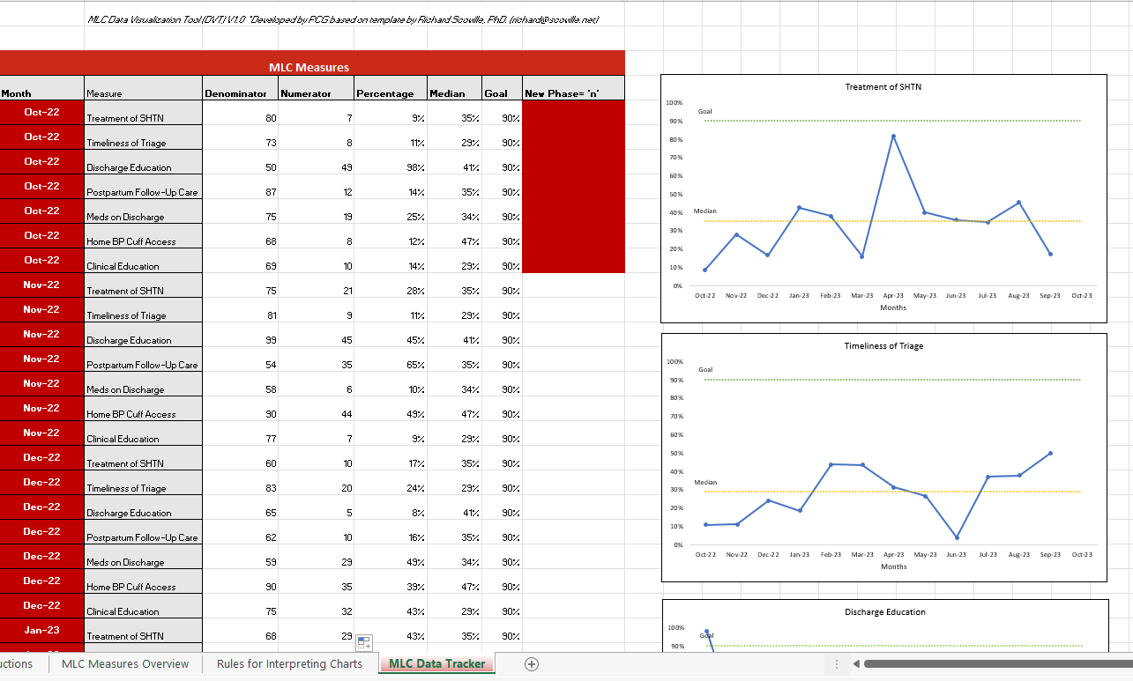
- An instructional video on how to use the tool can also be found in the MLC portal.

IV. Sampling
Sampling is allowed. In QI we strive for at least 20 charts if sampling is your approach. You can indicate you are sampling within the Data Submission Survey.

V. Troubleshooting
If you are having issues using the Data Submission Survey or the Data Visualization Tool, please email QIP-NJ@pcgus.com with your questions.

This document does not provide guidance on the QIP-NJ Pay-for-Performance non-claims-based measure submission, which is a separate process tied to your hospital’s QIP-NJ payment. The QIP-NJ Pay-for-Performance measure specifications and instructions can be found in the QIP-NJ Measurement Specifications and Submission Guidelines (Databook), which is available on the Documents & Resources page of the QIP-NJ website.
The Measurement Strategy can be accessed here and via the MLC Participant Portal at this location: https://qip-nj.nj.gov/Account/Login?userType=MH. MLC participants must have an account created to access the portal. See Section I of this document for more information on creating a Portal account.

